**Lab Session 07**



**Conditional Processing**



**Boolean Instructions**

* **AND**

Boolean AND operation between a source operand and destination operand.

**Syntax:** *AND reg, reg*

*AND reg, mem*

*AND reg, imm*

*AND mem, reg*

*AND mem, imm*

* **OR**

Boolean OR operation between a source operand and destination operand.

**Syntax:** *OR reg, reg*

*OR reg, mem*

*OR reg, imm*

*OR mem, reg*

*OR mem, imm*

* **XOR**

Boolean XOR operation between a source operand and destination operand.

**Syntax:** *XOR reg, reg*

*XOR reg, mem*

*XOR reg, imm*

*XOR mem, reg*

*XOR mem, imm*

* **NOT**

Boolean NOT operation on a destination operand.

**Syntax:** *NOT reg*

*NOT mem*

* **TEST**

Similar to AND operation, except that instead of affecting any operands it sets the FLAGS appropriately.

**Syntax:** *TEST reg, reg*

*TEST reg, mem*

*TEST reg, imm*

*TEST mem, reg*

*TEST mem, imm*

**EXAMPLE # 01:**

.code

mov al, 10101110b ; Clear only bit 3

and al, 11110110b ; AL = 10100110

mov al, 11100011b ; set bit 2

or al, 00000100b ; AL = 11100111

mov al, 10110101b ; 5 bits means odd parity

xor al, 0 ; PF = 0 (PO)

mov al, 10100101b ; 4 bits means even parity

xor al, 0 ; PF = 1 (PE)

mov al, 11110000b

not al ; AL = 00001111b

mov al, 00100101b

test al, 00001001b ; ZF = 0

mov al, 00100101b

test al, 00001000b ; ZF = 1

call DumpRegs

exit

**Set Operations (using Boolean instructions)**

* **Set Complement**

The complement of a set can be achieved through NOT instruction.

* **Set Intersection**

The intersection of two sets can be achieved through AND instruction.

* **Set Union**

The union of two sets can be achieved through OR instruction.

**EXAMPLE # 02:**

.data

A DWORD 10000000000000000000000000000111b

B DWORD 10000001010100000000011101100011b

msg1 BYTE "A intersection B is: ", 0

msg2 BYTE "A union B is: ", 0

msg3 BYTE "Complement of A is: ", 0

.code

mov eax,A

and eax, B ; A intersection B

mov edx, OFFSET msg1

call WriteString

mov ebx, TYPE DWORD

call WriteBinB

call Crlf

mov eax, A

or eax, B ; A union B

mov edx, OFFSET msg2

call WriteString

mov ebx, TYPE DWORD

call WriteBinB

call Crlf

mov eax, A

not eax ; A complement

mov edx, OFFSET msg3

call WriteString

mov ebx, TYPE DWORD

call WriteBinB

exit

**CMP instruction**

CMP (compare) instruction performs an implied subtraction of a source operand from a destination operand for comparison.

For unsigned operands:

* Destination < source ZF = 0 CF = 1
* Destination > source ZF = 0 CF = 0
* Destination = source ZF = 1 CF = 0

For signed operands:

* Destination < source SF ! = OF
* Destination > source SF = OF
* Destination = source ZF = 1

**EXAMPLE # 03:**

.code

mov ax, 5

cmp ax, 10 ; ZF = 0 and CF = 1

mov ax, 1000

cmp ax, 1000 ; ZF = 1 and CF =0

mov si, 106

cmp si, 0 ; ZF = 0 and CF = 0

exit

**Conditional Jumps**

* **Jumps based on Flag values**

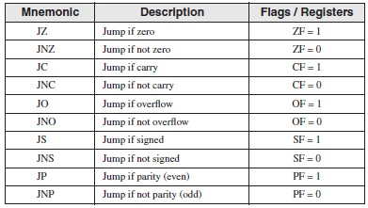

* **Jumps based on Equality**

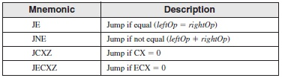

* **Jumps based on unsigned comparisons**

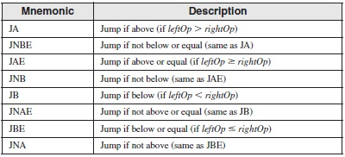

* **Jumps based on signed comparisons**

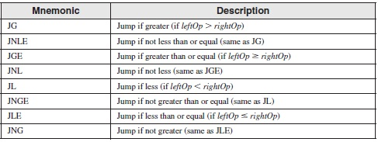

**EXAMPLE # 04:**

; This program compares and finds larger of the two integers

.data

var1 DWORD 250

var2 DWORD 125

larger DWORD ?

.code

mov eax, var1

mov larger, eax

mov ebx, var2

cmp eax, ebx

jae L1

mov larger, ebx

L1:

exit

**EXAMPLE # 05:**

; This program compares and finds smallest of the three integers

.data

var1DWORD 50

var2DWORD 25

var3DWORD 103

msg BYTE "The smallest integer is: ", 0

.code

mov eax, var1

cmp eax, var2

jbe L1

mov eax, var2

L1:

cmp eax, var3

jbe L2

mov eax, var3

L2:

mov edx, OFFSET msg

call WriteString

call WriteDec

exit

**EXAMPLE # 06:**

; The following program continues a loop until an alphanumeric key is pressed

.data

char BYTE ?

.code

L1:

mov eax, 10 ; create 10ms delay

call Delay

call ReadKey ; reads a key input

jz L1 ; repeat if no key is pressed

mov char, al ; saves the character

**ACTIVITIES:**

1. Translate the following pseudo-code to Assembly Language:

(a)

**var = 5**

**if ( var<ecx ) AND (ecx>=edx) then**

**x = 0**

**else**

**x = 1**

(b)

**var = 0**

**while(var<= 10)**

**if (var % 2 == 0)**

**Print “Hello”**

**else**

**Print “World”**

**var = var + 1**

**end while**

**3**. Use cmp and jumps to find the first non-zero value in the given array:  
 **intArr SWORD 0, 0, 0, 0, 1, 20, 35, -12, 66, 4, 0**

4. Write a program that takes four input integers from the user. Then compare and display a message whether these integers are equal or not.

6. Write a program for sequential search. Take an input from the user and find if it occurs in the following array:

**arr WORD 10, 4, 7, 14, 299, 156, 3, 19, 29, 300, 20**

7. Translatethe followingpseudo-codeto Assembly Language:

**Swap_Count = 0**

**for all elements of list**

**if list[i] > list[i+1]**

**swap(list[i], list[i+1])  
 Swap_Count = Swap_Count + 1**

**end if**

**end for**

**Print Swap_Count**